- Weekly Review & Practice Practical

Q1. On Cisco Packet Tracer, create a network with three switches and assign at least two different VLANs (e.g., VLAN 10 for 'Sales', VLAN 20 for 'Support'). Connect two PCs to each switch and assign each PC to the correct VLAN based on department?

Answer
- I set up three Cisco 2960 switches in Packet Tracer and added two department VLANs: VLAN 10 for Sales and VLAN 20 for Support.
- On every switch, I placed port FastEthernet0/2 in the Sales VLAN and FastEthernet0/3 in the Support VLAN.
- To inspect the VLAN assignments, I entered the show vlan brief command on the switches.
- The output confirmed that VLANs 10 and 20 were available and active on all three switches.
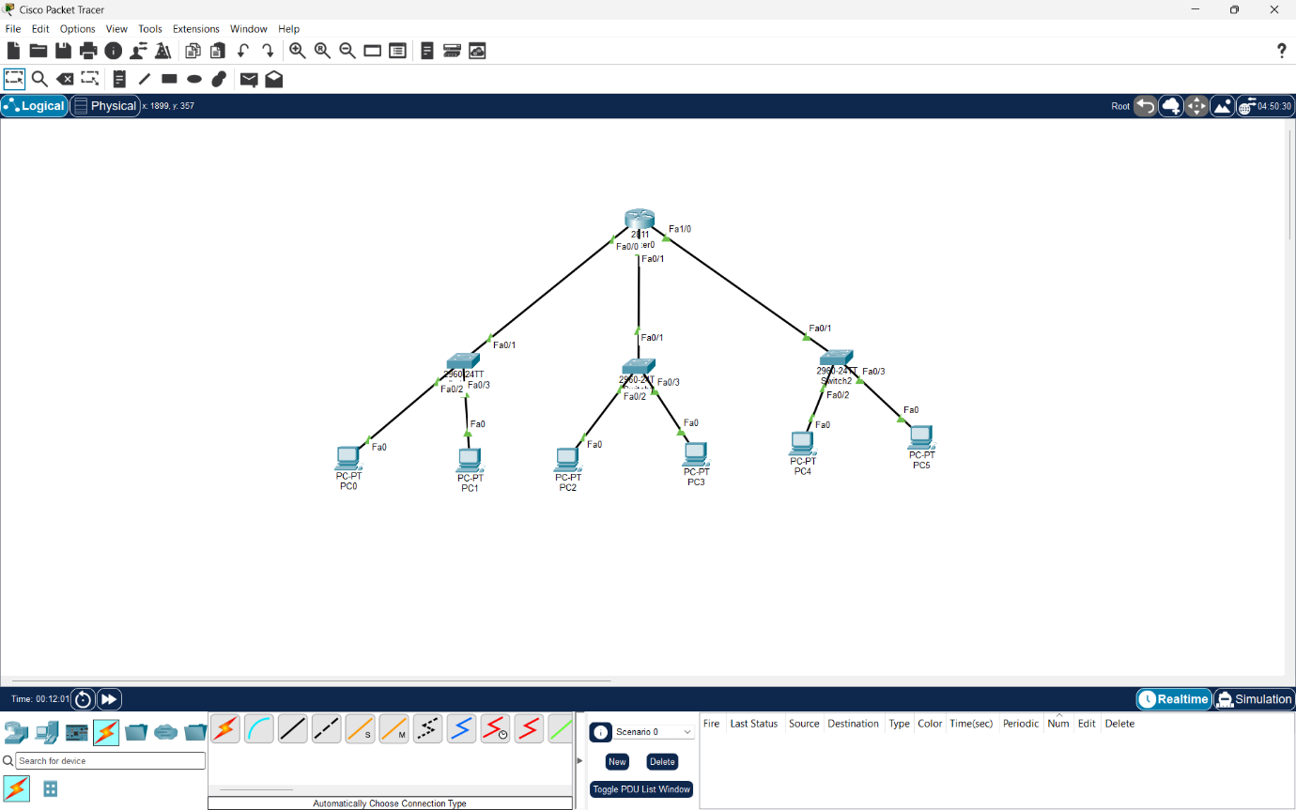

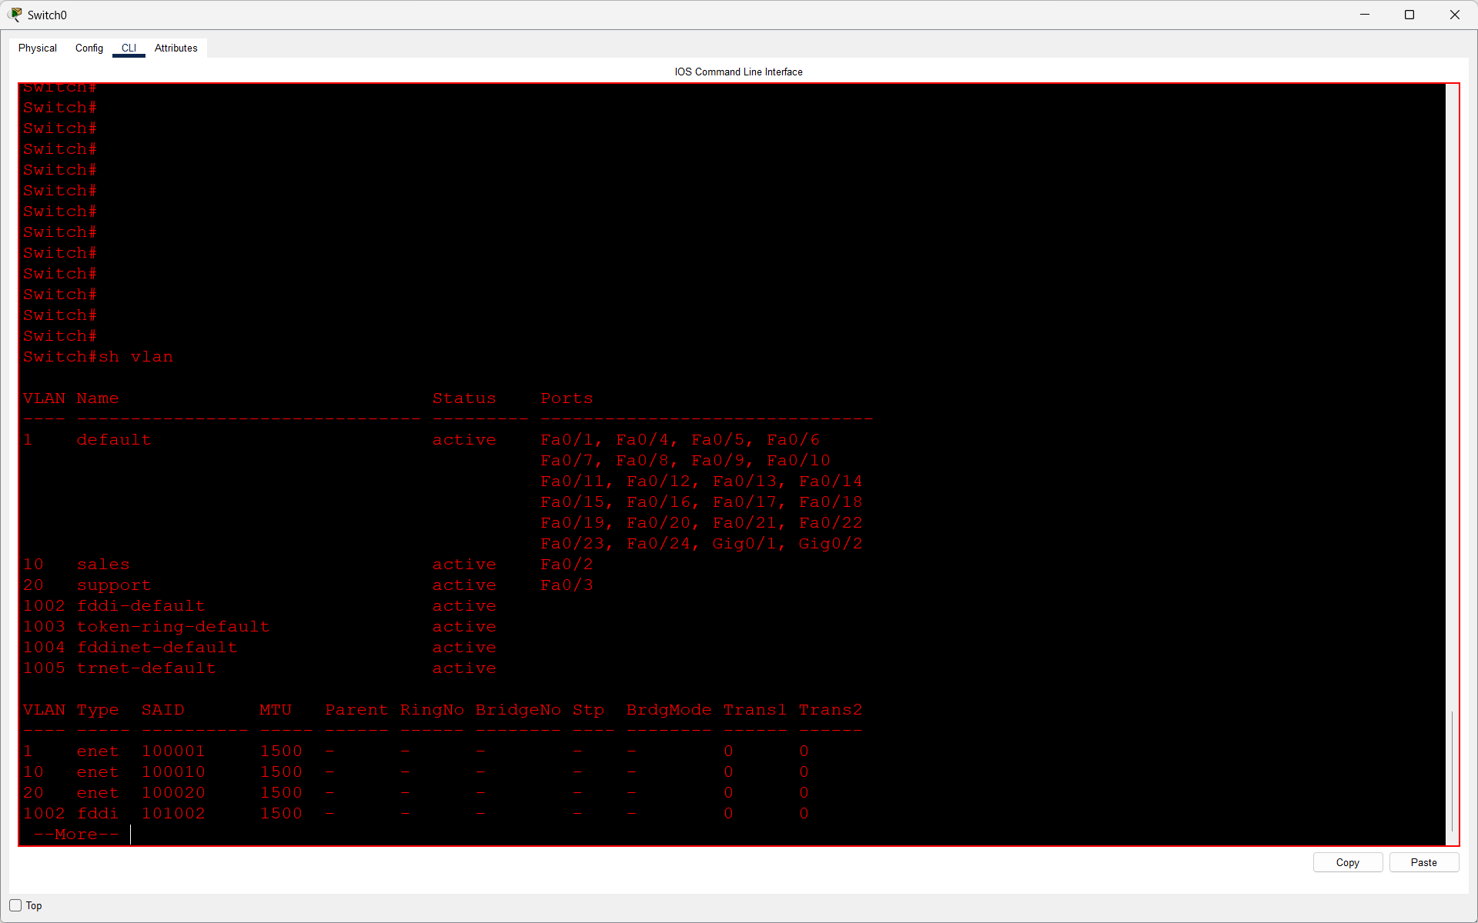
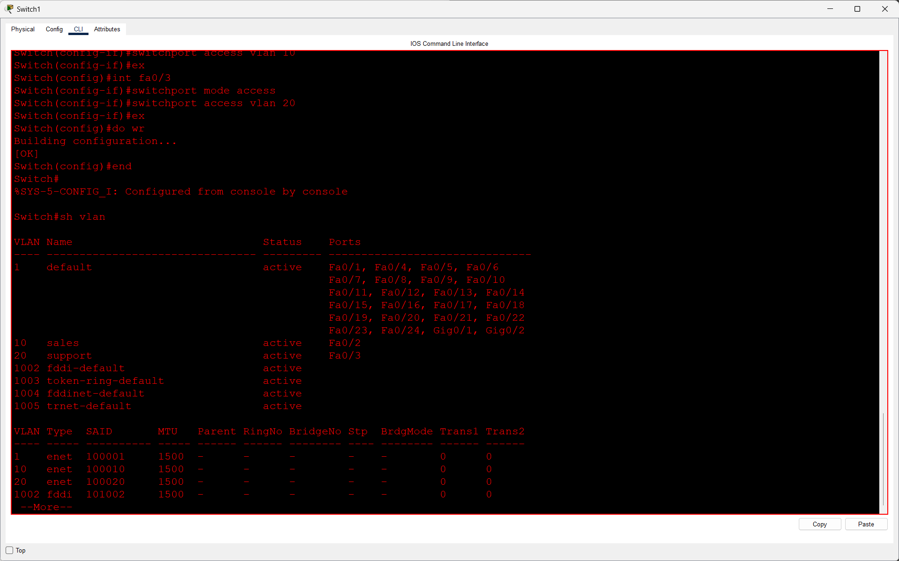
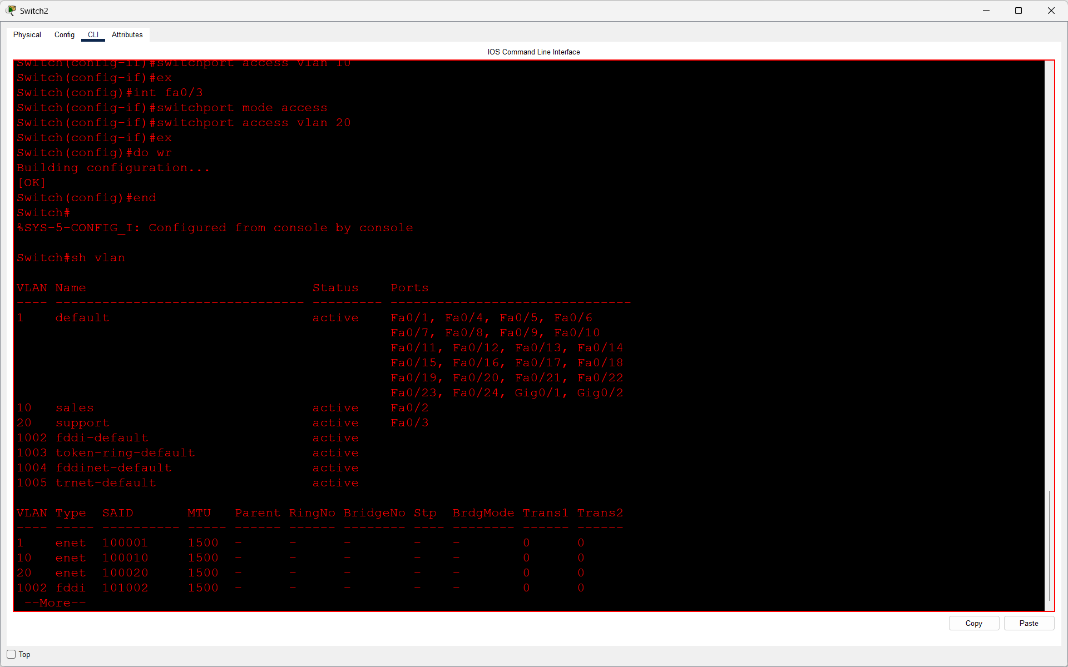

Q2. Configure trunk ports between the switches to allow VLAN traffic to pass through. Verify trunking by using the show interfaces trunk command and submit a screenshot of the output?

Answer
- I enabled trunk mode on the links connecting the three switches by entering switchport mode trunk.
- These trunk links used 802.1Q so traffic belonging to both VLAN 10 and VLAN 20 could travel between switches.
- I checked the trunk status using show interfaces trunk after applying the configuration.
- The verification output listed the selected switch ports as operating in trunk mode.

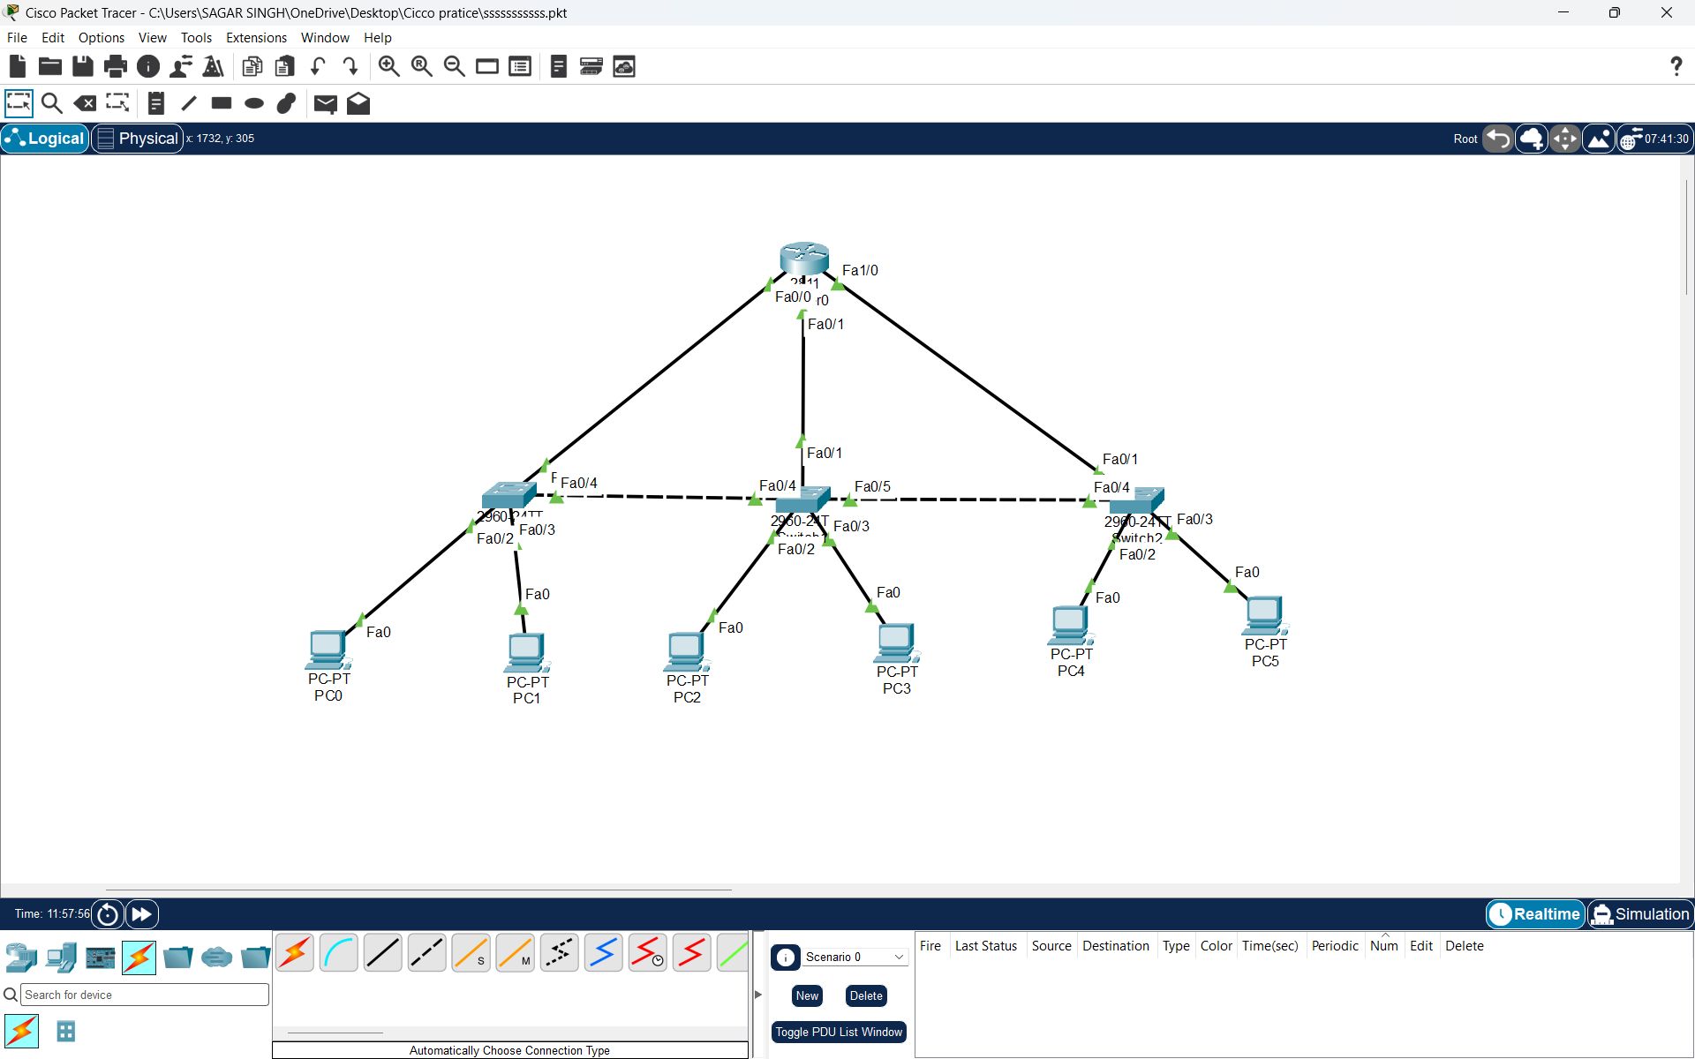
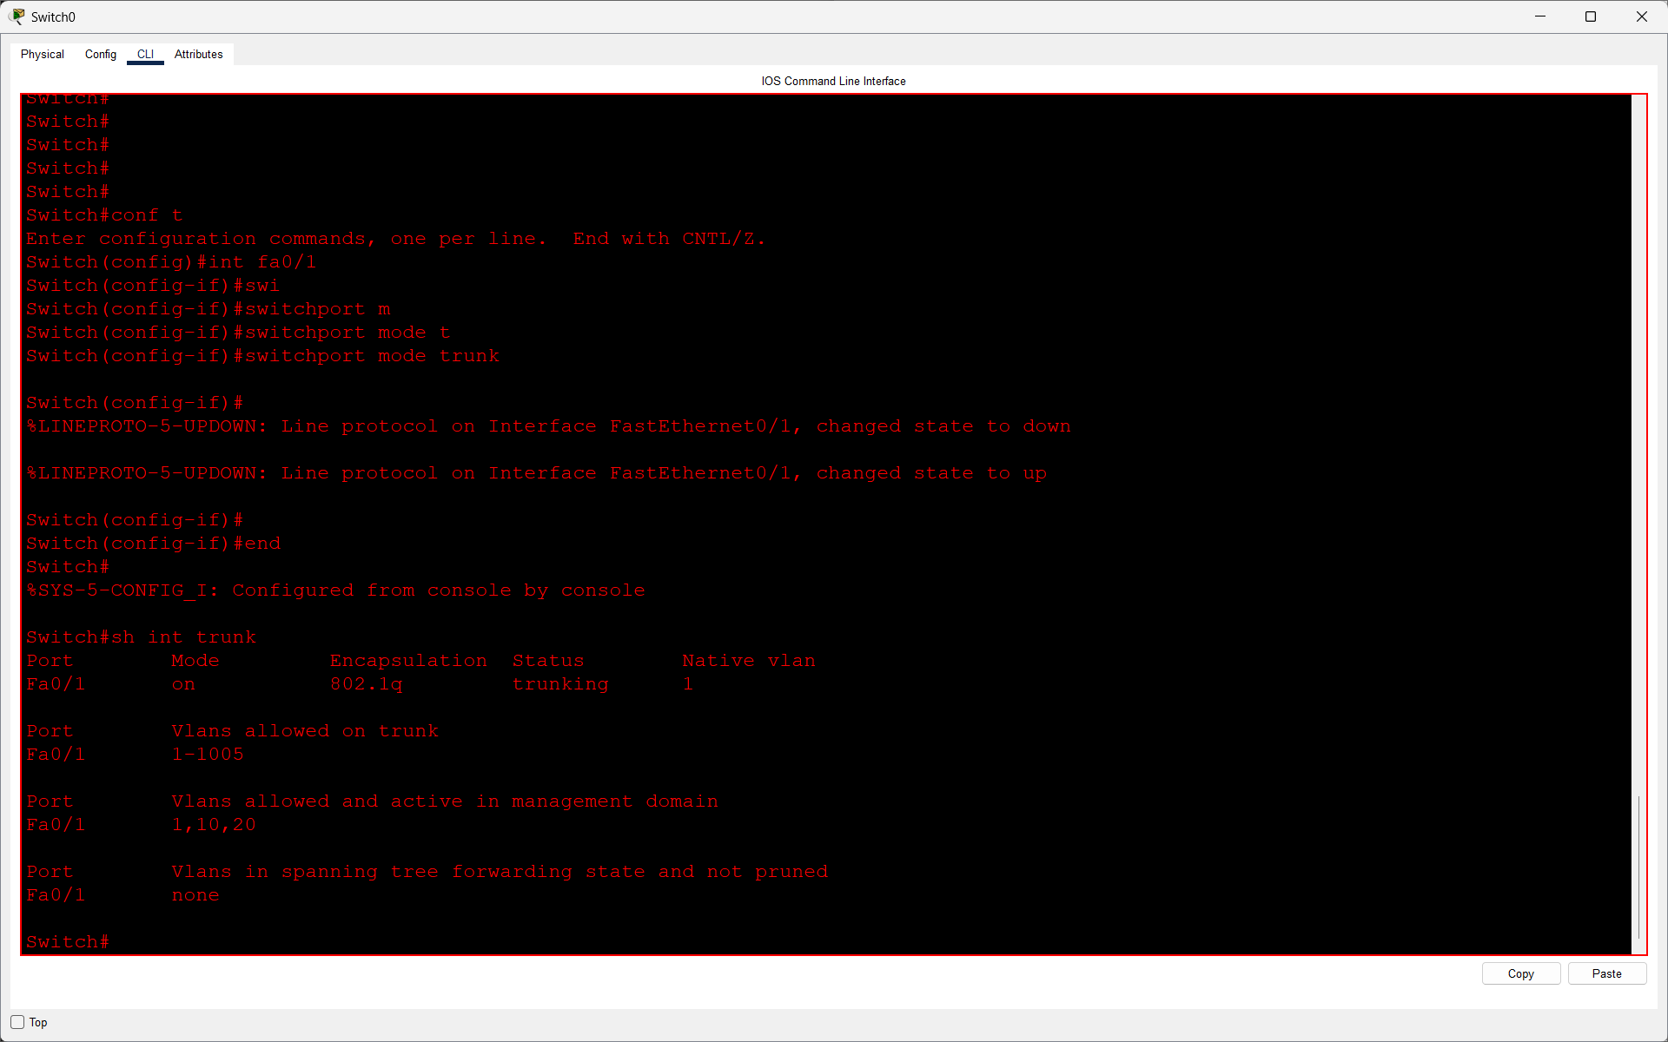
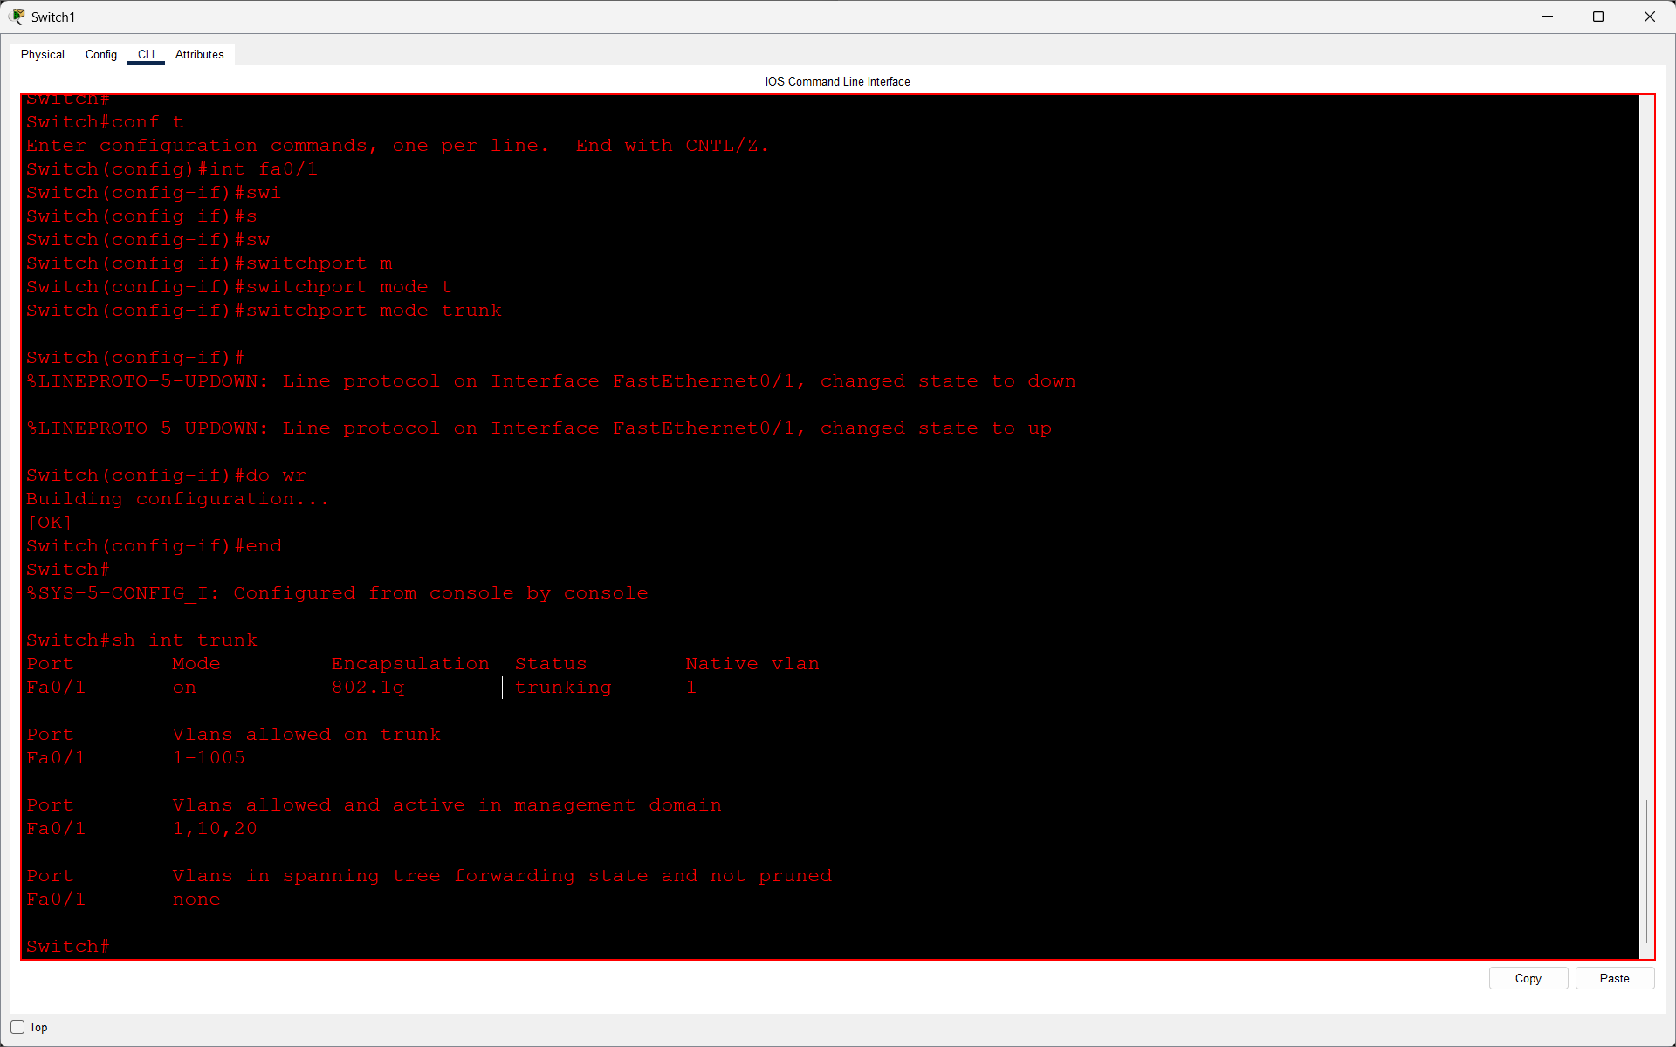
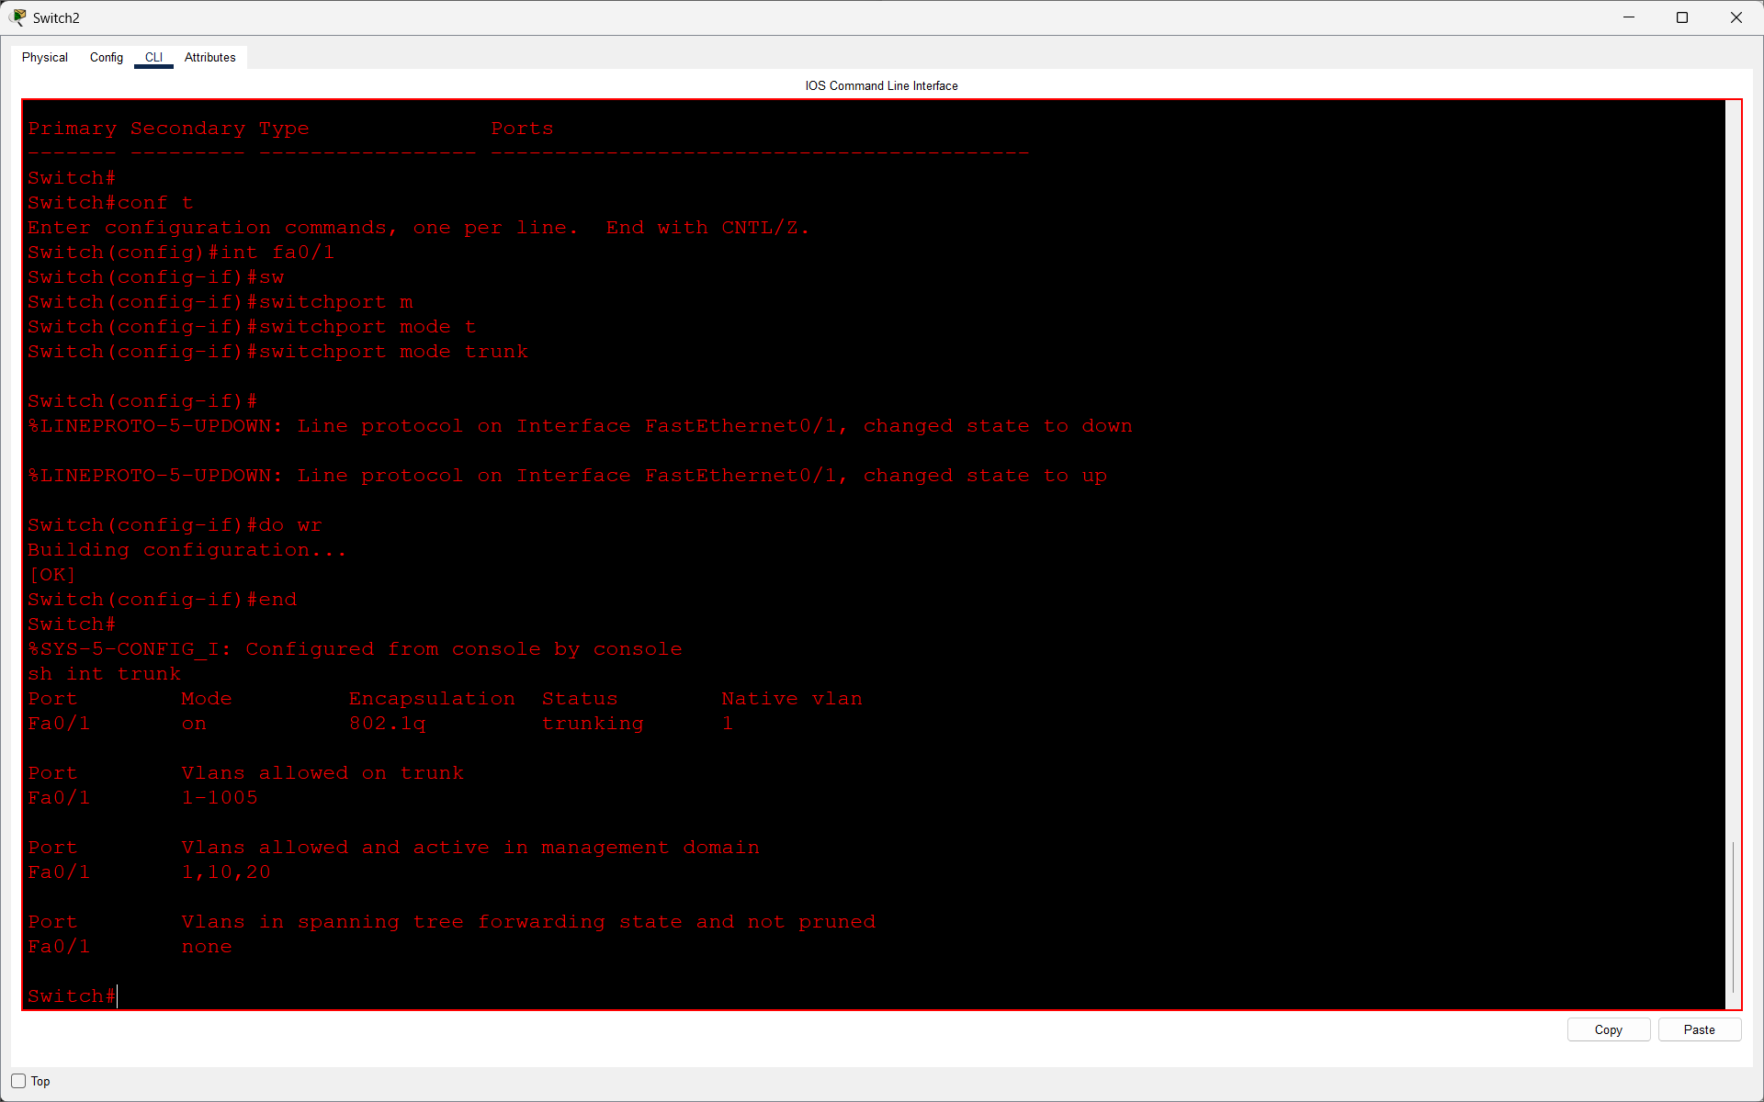

Q3. Set up a Layer 3 device (Router-on-a-Stick using a router or a multilayer switch) to enable inter-VLAN routing between VLAN 10 and VLAN 20. Assign appropriate sub-interfaces and IP addresses for each VLAN?

Answer
- For communication between the two VLANs, I used a Cisco 2811 router connected to the three-switch setup in a router-on-a-stick arrangement.
- I set up a separate router sub-interface for VLAN 10 and VLAN 20, applied 802.1Q tagging, and provided an IP address for each VLAN interface.
- I checked the interface details with show ip interface brief and then confirmed that devices in the two VLANs could communicate.
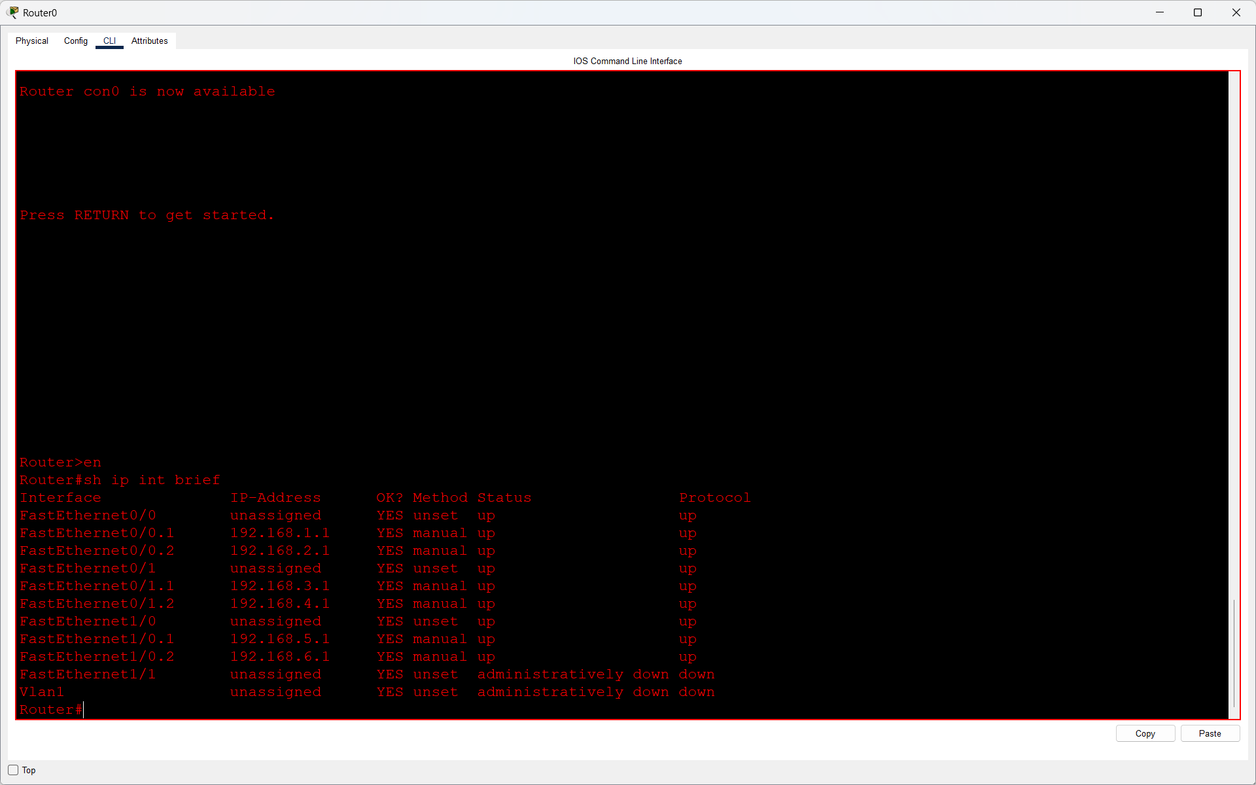
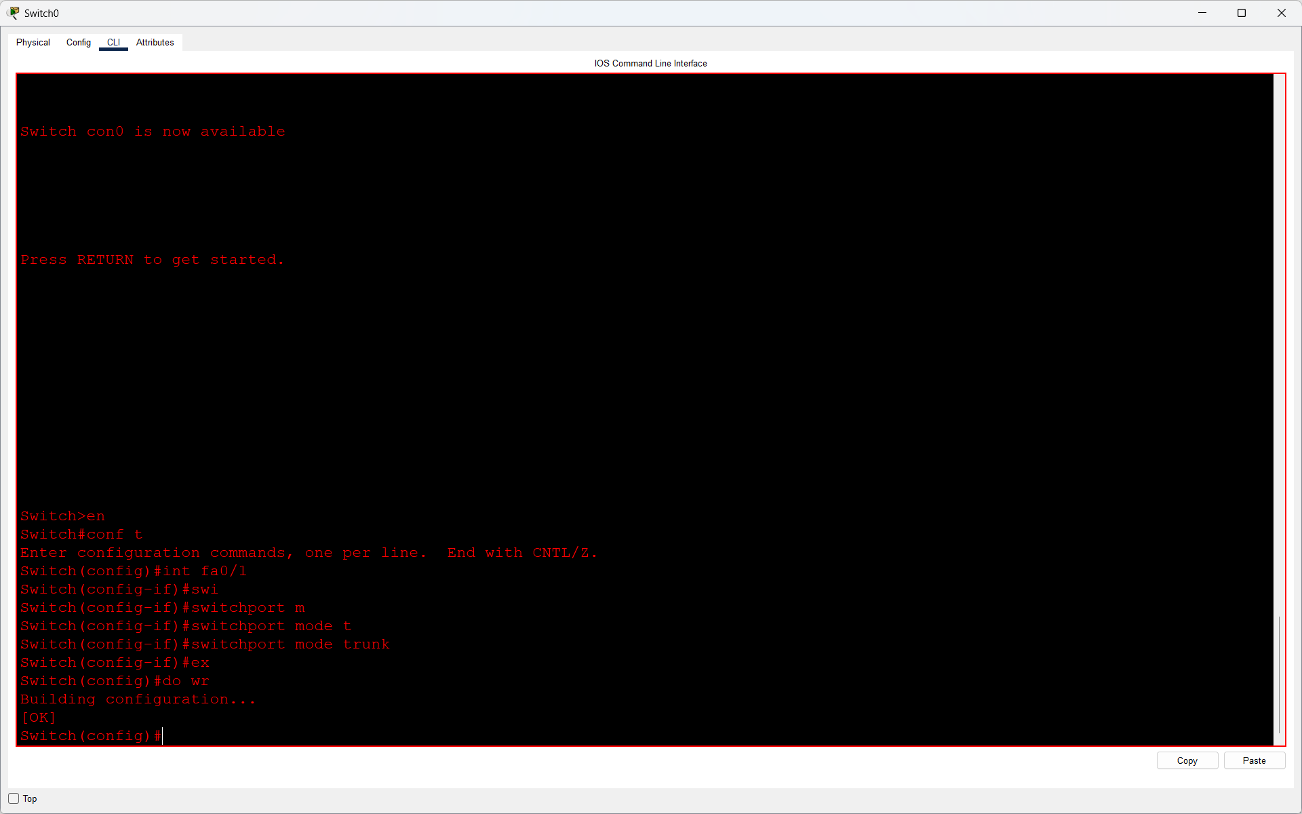

Q4. Test connectivity by pinging between a PC in VLAN 10 and a PC in VLAN 20. If pings fail, troubleshoot and fix the configuration so that inter-VLAN communication works.<br><br><em><strong>Hint:</strong> Check sub-interface IPs, trunk configuration, and default gateways on PCs.</em>?

Answer
- I checked whether a PC assigned to VLAN 10 could reach a PC assigned to VLAN 20 by sending ping requests in Packet Tracer.
- The first attempts did not work, so I reviewed the router sub-interface settings, trunk connections, PC IP configuration, and default gateway entries.
- After correcting the configuration, I repeated the ping test and received successful replies.
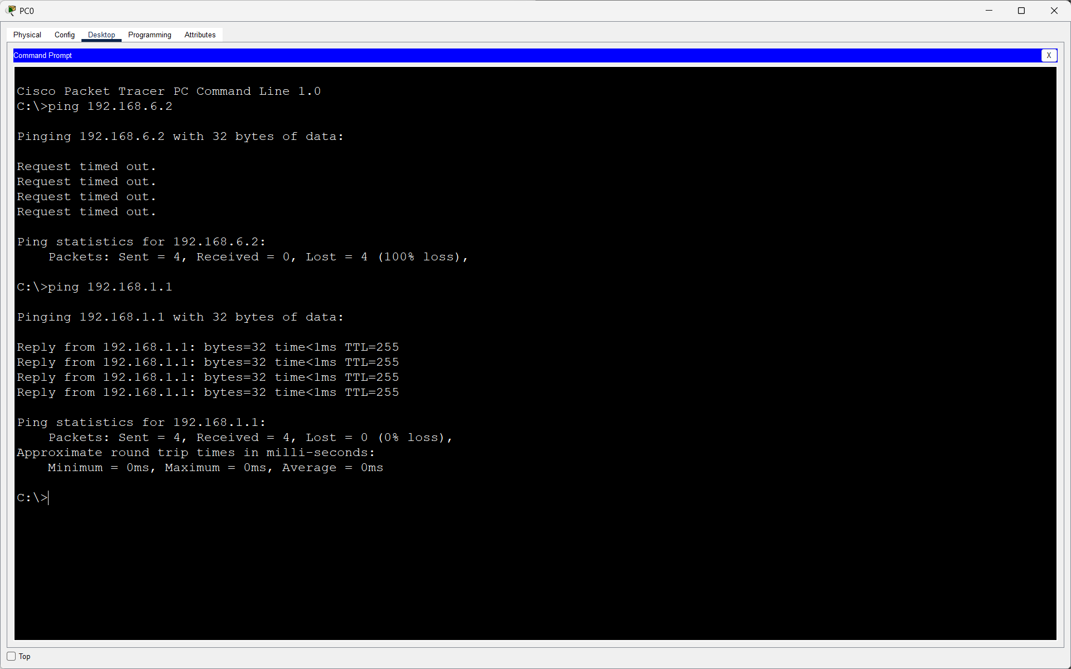
- Result: The PCs in VLAN 10 and VLAN 20 were able to communicate through inter-VLAN routing.

